Application to make the Gas filling Station easy using CRM ( admin )

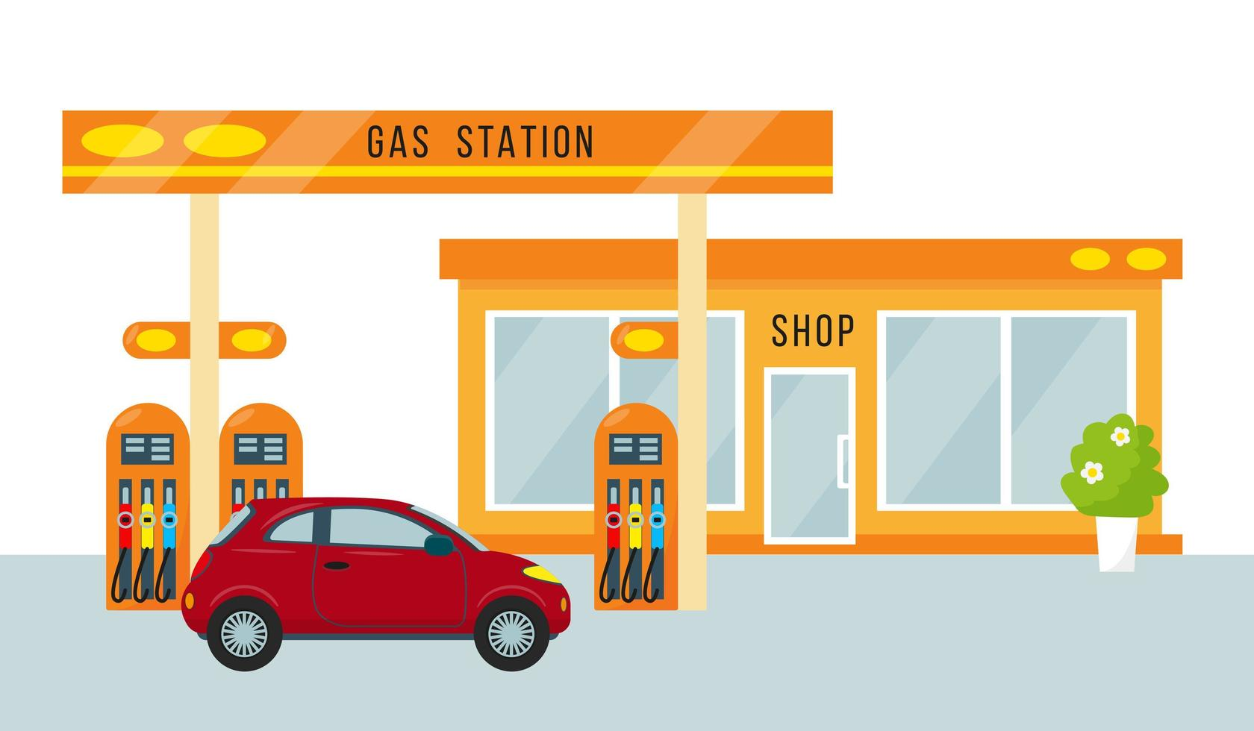

BY

**Kommoju Varaha Venkata Siva Surya Pavani**

pavanikommoju2003@gmail.com

Lendi Institute of Engineering and Technology

Abstract:

The integration of **Customer Relationship Management (CRM)** systems into gas filling stations revolutionizes administrative processes, making them more streamlined and efficient. By leveraging CRM technology, gas stations can effectively manage customer interactions, track sales, and optimize inventory management. The CRM system facilitates real-time data collection and analysis, allowing administrators to monitor fuel levels, anticipate customer needs, and schedule refills proactively. This ensures a steady supply of fuel, reduces downtime, and enhances overall operational efficiency, ultimately leading to improved customer satisfaction.

Moreover, the CRM system automates various administrative tasks such as billing, customer inquiries, and loyalty programs, thereby reducing the workload on staff and minimizing the risk of human error. This automation allows for better resource allocation and frees up staff to focus on more strategic activities. Additionally, the system can generate detailed reports and insights on sales trends, customer preferences, and inventory turnover, providing valuable data for informed decision-making. This data-driven approach helps in identifying opportunities for cost savings, revenue growth, and enhanced service delivery.

Adopting a CRM system in gas filling stations not only simplifies administrative tasks but also provides a competitive edge by enabling personalized marketing strategies. By analyzing customer preferences and purchasing patterns, the CRM system allows for targeted promotions and loyalty rewards, fostering customer loyalty and increasing sales. Furthermore, the system can enhance customer communication through personalized messages and offers, creating a more engaging and satisfying customer experience. In essence, the implementation of a CRM system transforms gas filling station operations, driving efficiency, profitability, and customer satisfaction.

INDEX:

* Salesforce
* Object
* Tabs
* The Lightning App
* Fields
* Page Layouts
* Profiles
* Role & Role Hierarchy
* Users
* Permission Sets
* Setup For OWD
* User Adoption
* Reports
* Dashboards
* Flows

**Salesforce:**

Salesforce is your customer success platform, designed to help you sell, service, market, analyze, and connect with your customers.Salesforce has everything you need to run your business from anywhere. Using standard products and features, you can manage relationships with prospects and customers, collaborate and engage with employees and partners, and store your data securely in the cloud.



### Creating Developer Account:

* By using the link **https://developer.salesforce.com/signup**

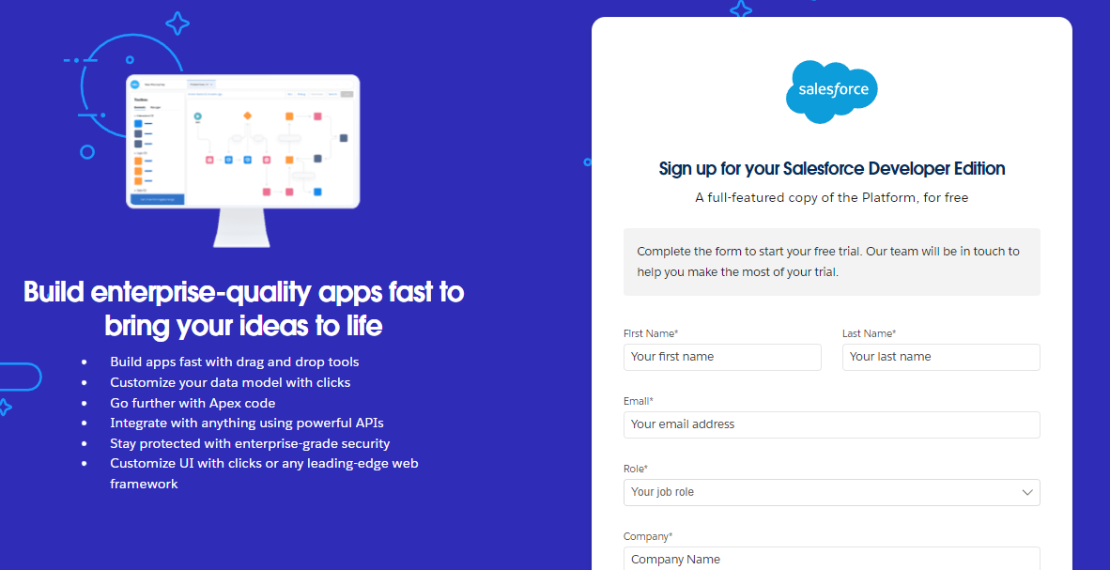

1. First name & Last name
2. Email
3. Role : Developer
4. Company : College Name
5. County : India
6. Postal Code : pin code

### Account Activation:

### Go to inbox mail and verify account

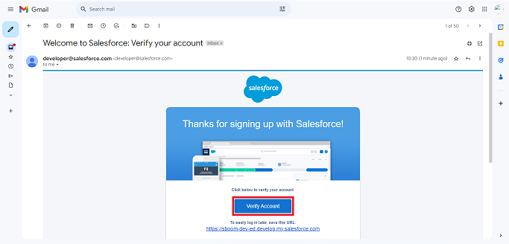

* Give a password and answer a security question and click on change password

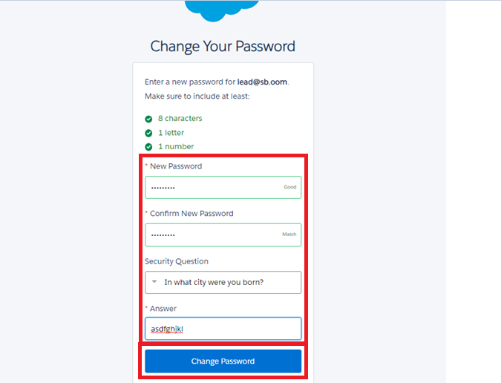

* 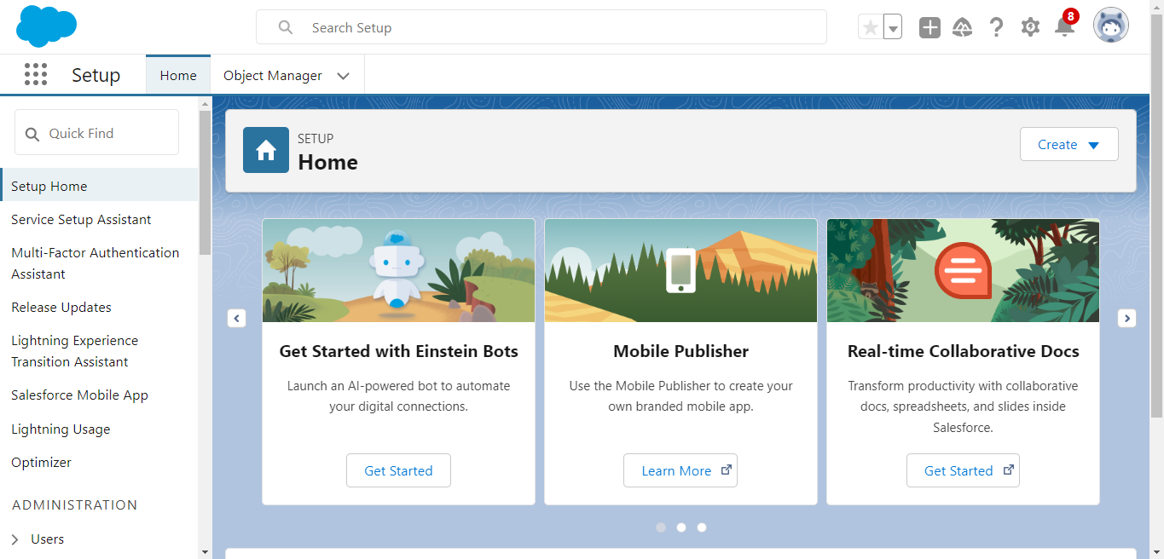It will REDIRECT to the Salesforce Main Page

**Object:**

In Salesforce, an object is a database table that allows you to store and manage data related to your organization. Objects can be standard (provided by Salesforce) or custom (created by users to meet specific business needs). Each object contains a set of fields that represent the data points stored within it, and records, which are individual entries in the object.

**Standard Objects**: Salesforce comes with several built-in standard objects designed to manage common business processes. Examples like Accounts,Contacts,Opportunity etc...

**Custom Objects**: Custom Objects are the objects that are Created by the Users.

* From setup page go for the object manager and create the object

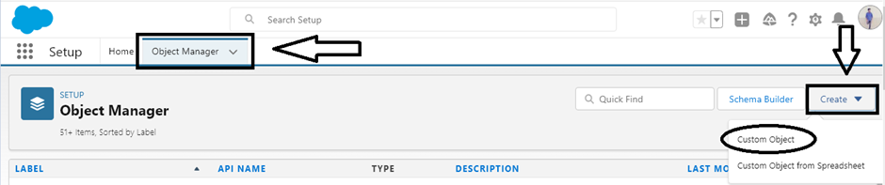

* Enter the Required Details and Save.

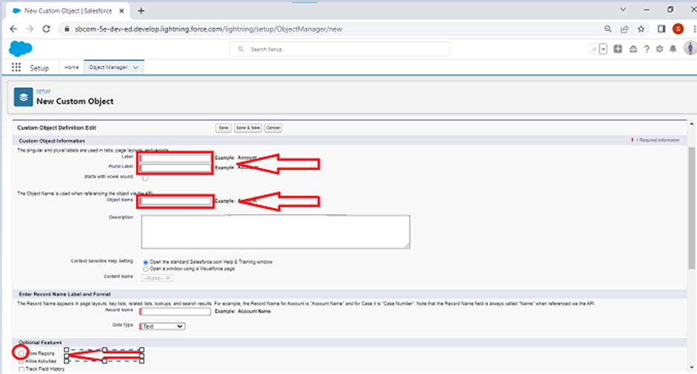

* By using the above information create objects with the names of Supplier,Gas Station,Buyer,Fuel Details.

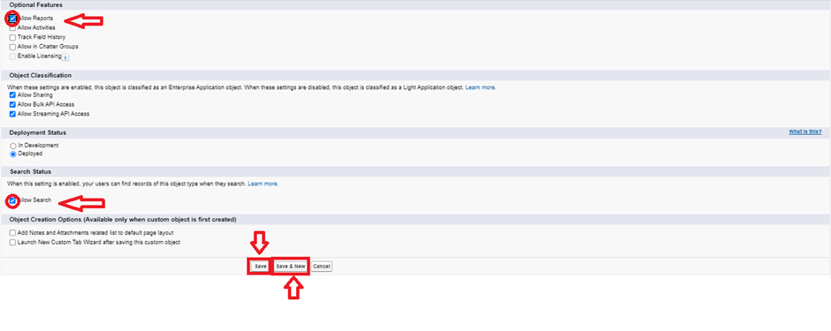

To create an object:

* From the setup page ? Click on Object Manager ? Click on Create ? Click on Custom Object.
* Enter the label name? Supplier
* Plural label name? Suppliers
* Enter Record Name Label and Format
* Record Name ? Supplier Name
* Data Type ? Name
* Click on Allow reports and Track Field History,
* Allow search ? Save.

To create an object for Gas Station:

* From the setup page ? Click on Object Manager ? Click on Create ? Click on Custom Object.
* Enter the label name? Gas Station
* Plural label name? Gas Stations
* Enter Record Name Label and Format
* Record Name ? Gas Station
* Data Type ? Auto Number
* Display Format ? Gas-{000}
* Starting number ? 1
* Click on Allow reports and Track Field History,
* Allow search ? Save
* Do follow for the Buyer and Fuel Details.

**Tabs:**

A tab is like a user interface that is used to build records for objects and to view the records in the objects.

Creating a Custom Tab

* **To create a Tab:(supplier)**
* Go to the setup Page ->Click on Quick Find->Tabs->New.

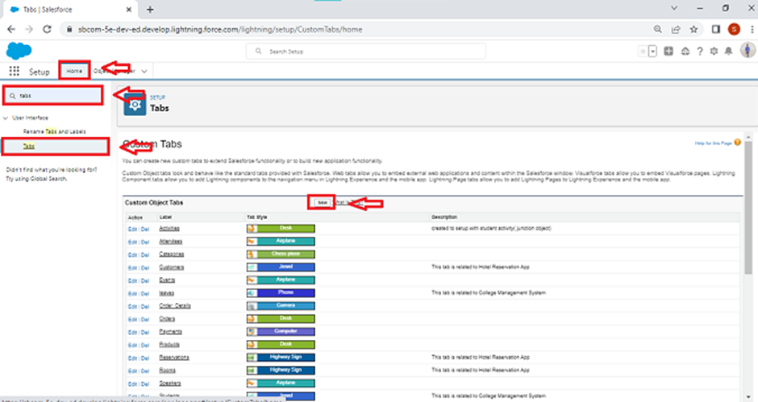

* Select object(Suppliers)->select any tab style->Next->Next(uncheck the tabs) and make sure to check the append tab to users->click on save.

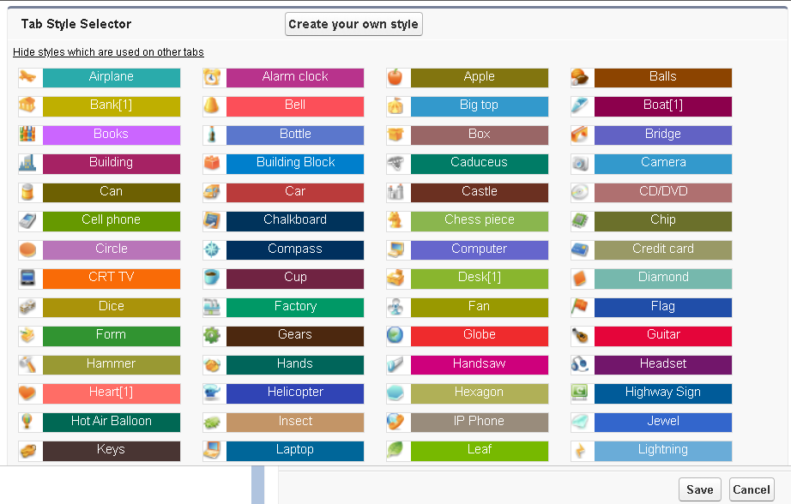

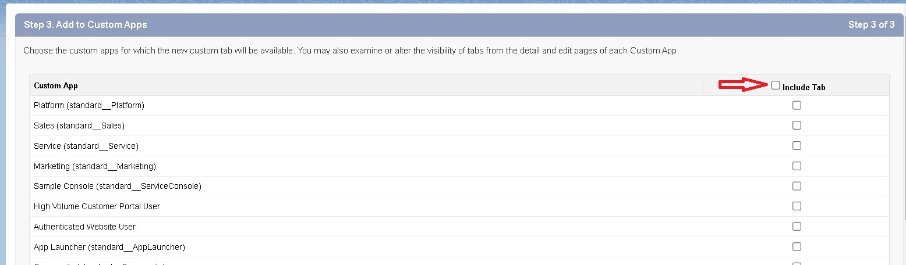

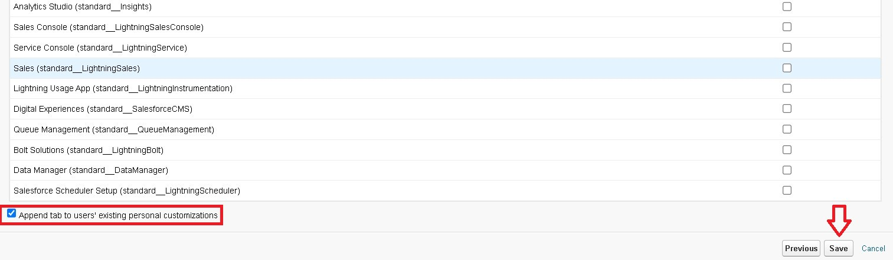

### Creating Remaining Tabs

1. Now create the Tabs for the remaining Objects, they are “ Gas station, Buyer, Fuel details”.
2. Follow the same steps as mentioned in above.

### The Lightning App:

The Lightning App in Salesforce is a customizable application framework designed to enhance the user experience by providing a modern, efficient, and intuitive interface. Built on the Salesforce Lightning platform, Lightning Apps enable organizations to tailor their Salesforce environment to meet specific business needs, streamline workflows, and boost productivity.

### Create a Lightning App

**To create a lightning app page:**

* Go to setup page ->search “app manager” in quick find ->select “app manager” ->click on New lightning App->fill the app name as Gas Station->next->next->next

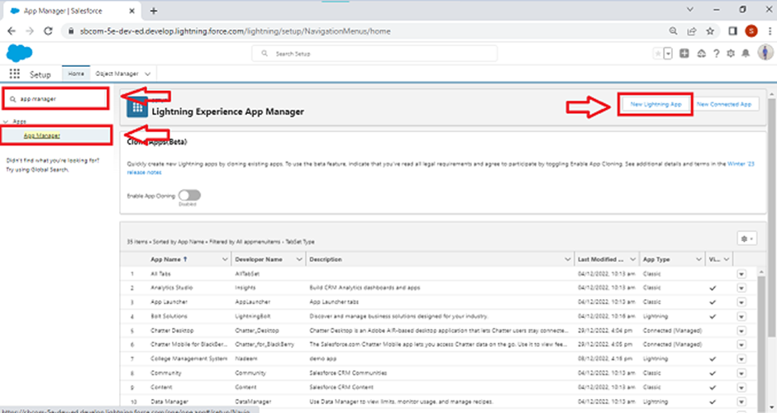

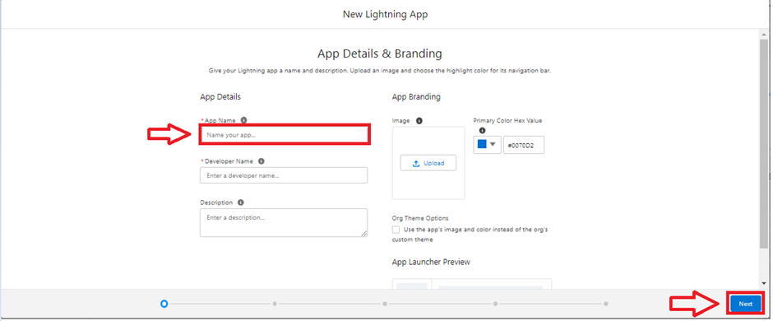

**Now add the Navigation Items** :Select the items (Supplier, Gas Station, Buyer, Receipt ) from the search bar and move it using the arrow button ? text.

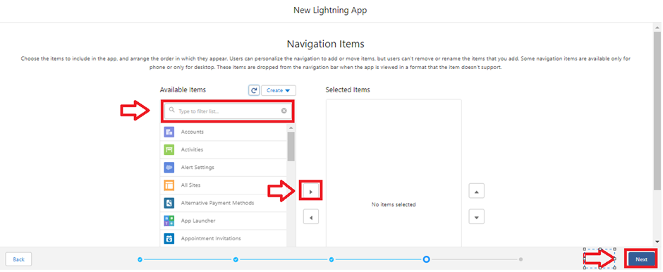

**To Add User Profiles:**

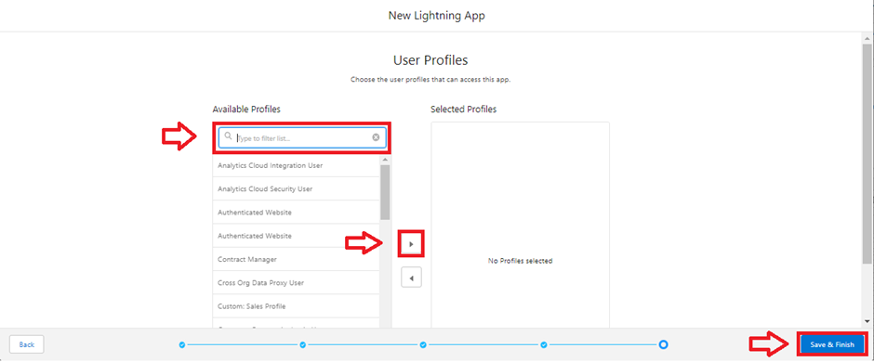

* Search profiles (System administrator) in the search bar ->click on the arrow button ->save & finish.

**Fields:**

Fields in Salesforce are fundamental elements used to store data within objects. They represent the individual pieces of information or data points that users can input and manage in Salesforce records. As a Salesforce Admin, understanding and managing fields is crucial for customizing the platform to meet business needs and ensuring data accuracy and integrity.

Types of Fields

1. Standard Fields
2. Custom Fields

### **Creating Junction Object****:**

**Creating junction object as Fuel details with Supplier & Gas station**

**To create junction object**

* Go to the setup page ->click on object manager->From drop down click edit for Fuel details object->Click on fields & relationship ->click on New.->Select “Master-Detail relationship” as data type and click Next->Select the related object “ Supplier ” and click next->Give Field Label as “Supplier Name” and click Next->Next -> Next -> Save & New.**Follow the same steps from 1 to 3-**>Select the related object “ Gas station ” and click Next->Give Field Label as “Gas Station” and click Next->Next-> Next->Save
* Below their is an overview of junction object for better understanding.

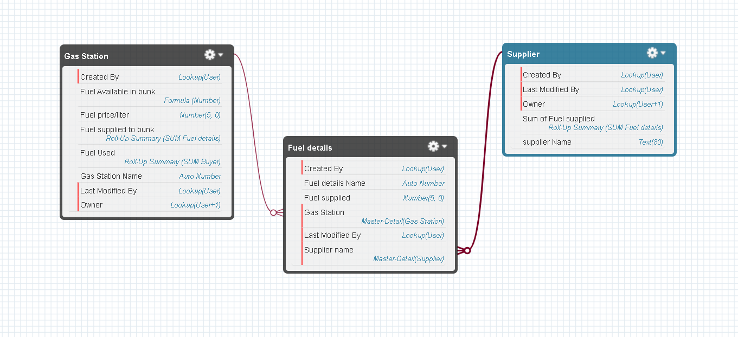

### Creating a Master-Detail Relationship

Master-detail relationship is a type of relationship between two objects where the master object controls certain behaviors and settings of the detail object. Here are a few use cases that demonstrate the use of master-detail relationships

**Creating Master-Detail Relationship between Buyer & Gas Station Object**

To Create a Master-Detail relationship

1. Go to the setup page -> click on object manager ->From drop down click edit for Buyer object.
2. Click on fields & relationship ->click on New.
3. Select “Master-Detail relationship” as data type and click Next.
4. Select the related object “ Gas station ”.
5. Give Field Label as “Gas Station name” and click Next.
6. Next -> Next -> Save.

### Creating the number field in Fuel details object

* Repeat step 1 and 2 mentioned in activity 1->Select Data type as “Number” ->click Next->Enter the Field Label as “ Fuel Supplied ” and length as “ 5 ”.

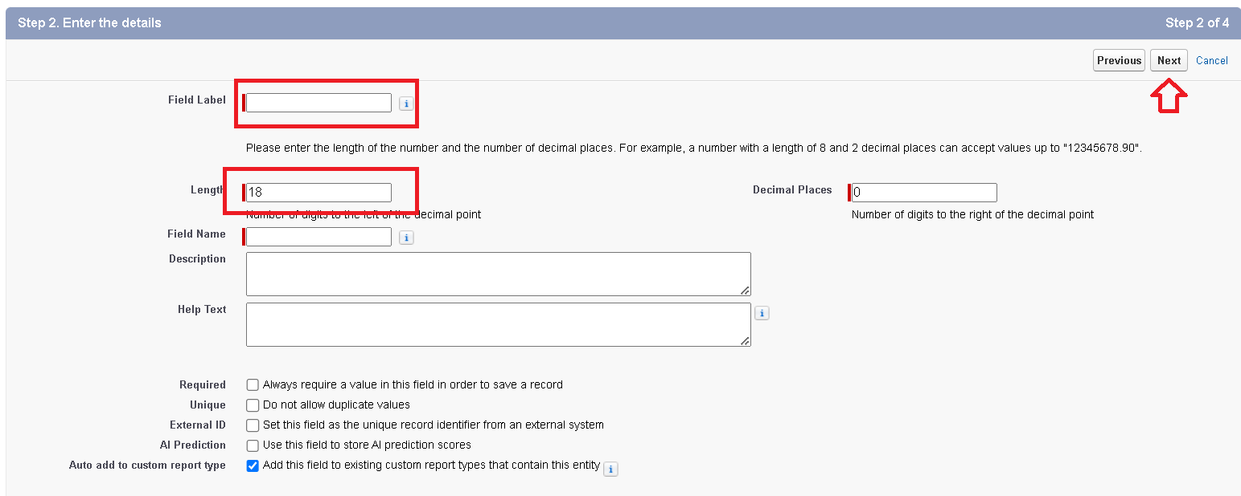

* Field name will be auto pop->click next->next->save

### Creating the Roll-up Summary:

* Go to setup -> click on Object Manager -> type object name(Supplier) in search bar -> click on the object->click on “Fields & Relationships” ->New ->data type as Rollup summary ,and click Next->Field label as “ sum of Fuel supplied ”,Field Name will be Auto generated, and click NextSelect the summarized object as “ Fuel details".Select the Rollup type as “sum”->Select the field to aggregate as “ Fuel supplied ”, and click Next ->Next -> Save.

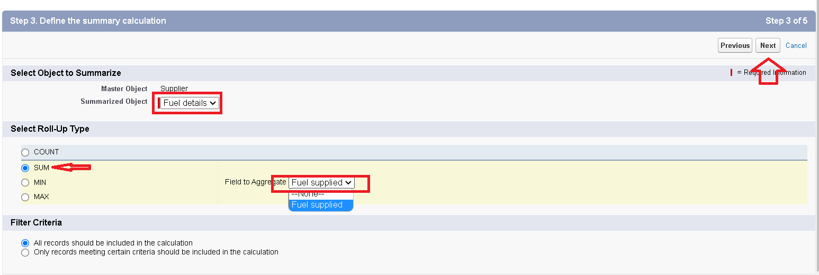

* Create Same for Gas Station  
  **Note :** create the field as “ Fuel filled in vehicle ” using number datatype in Buyer object.
* Follow the same steps for the Gas station Object from 1 to 3 Give the Field label as “ Fuel used ”,Field Name will be Auto generated, and click Next->Select the summarized object as “ Buyer”->Select the Rollup type as “sum”.->Select the field to aggregate as “ Fuel filled in vehicle ”, and click Next ->Next ->Save.

### Creating Formula Field in Gas Station Object:

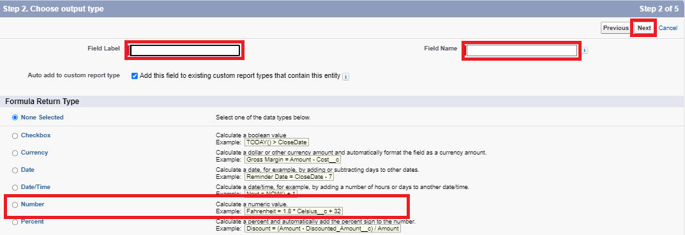

* Go to setup->object Manager->object name as Gas Station->Go to fields and Relationships->**Data type as “Formula”**->Give Field Label and Field Name as “Fuel Available in bunk” and select formula return type as “Number” and click next.

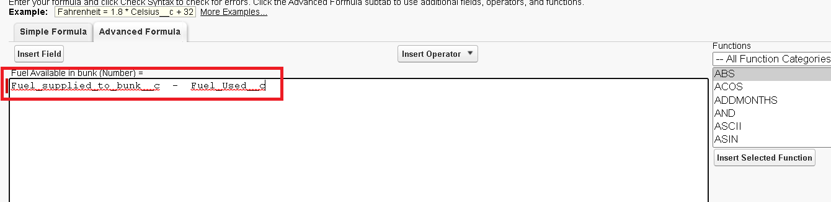

Create the same for Buyer Object

**Note** : check wheather that the fields that mentioned in the formula field are created are not , if not go to activity 9 and create that fields mentioned in Buyer object

* Go to setup ? click on Object Manager ? type object name(Buyer) in search bar ? click on the object.
* Click on fields & relationship ? click on New.
* Select Data type as “Formula” and click Next.
* Give Field Label and Field Name as “Customer Name” and select formula return type as “TEXT” and click next.
* Insert field formula should be : First_Name__c + ' ' + Last_Name__c
* click “Check Syntax” and Save.

### Creating Cross Object Formula Field in Buyer Object:

**Note** : check wheather that the fields that mentioned in the formula field are created are not , if not go to activity 9 and create that fields mentioned in Buyer object.

* Go to setup ? click on Object Manager ? type object name(Buyer) in search bar->click on the object.
* Click on fields & relationship-> click on New.
* Select Data type as “Formula” and click Next.
* Give Field Label and Field Name as “Amount Paid ” and select formula return type as “Number” and click next.
* Insert fields formula should be :

**Fuel_filled_in_vehicle__c * Gas_Station_name__r.Fuel_price_liter__c**

* Under Advanced Formula write down the formula and click “Check Syntax” and Save



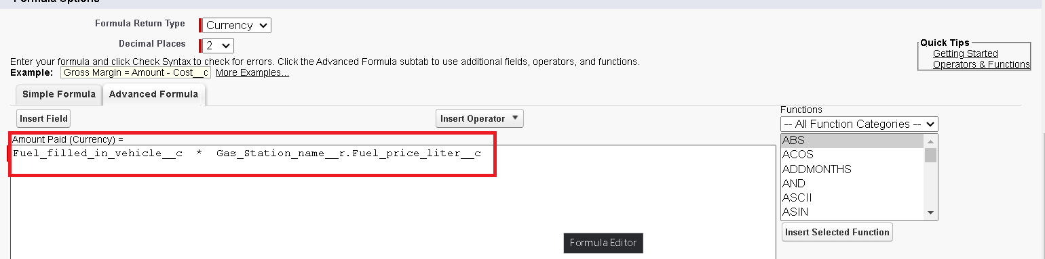

### Creating Picklist Field in Buyer Object:

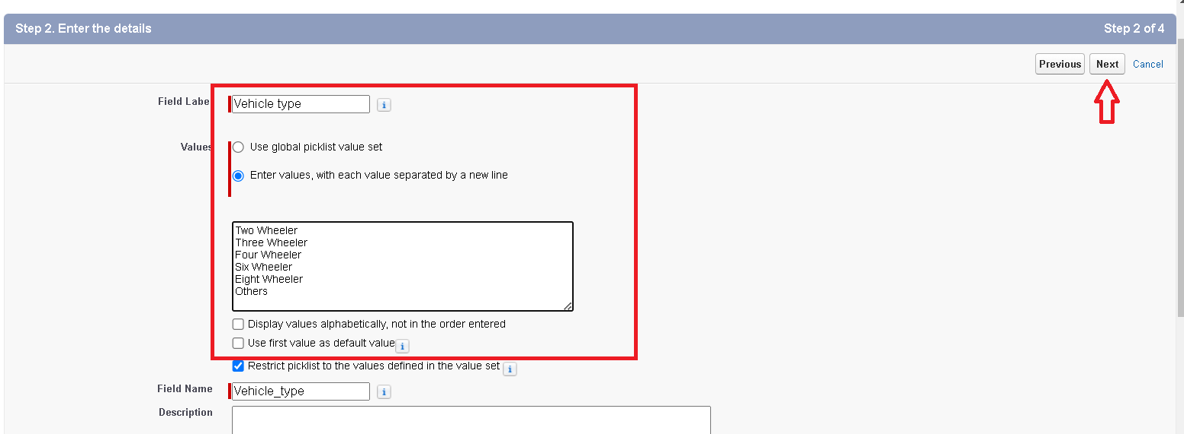

Go to the Object Manager->object name(Buyer)->click on fields and realationships->DataType as "Picklist"->Enter the field labels and names.Under values Enter

**two wheeler, three wheeler, four wheeler, six wheeler, eight wheeler and Others.**

* Repeat the process 1 and 2 steps .
* Enter Field Label as “Mode of payment”, under values select “Enter values, with each value separated by a new line" and enter values as shown below.
* The values are : credit card, debit card, net banking, upi, cash.
* Click Next.
* Next -> Next -> Save & New

### Creating the validation rule:

**Creating the validation rule for phone number field in Buyer object**

**Note** : check wheather that the fields that mentioned in the formula field are created are not , if not go to activity 9 and create that fields mentioned in Buyer object

* Go for the buyer object->click on validation rules->New

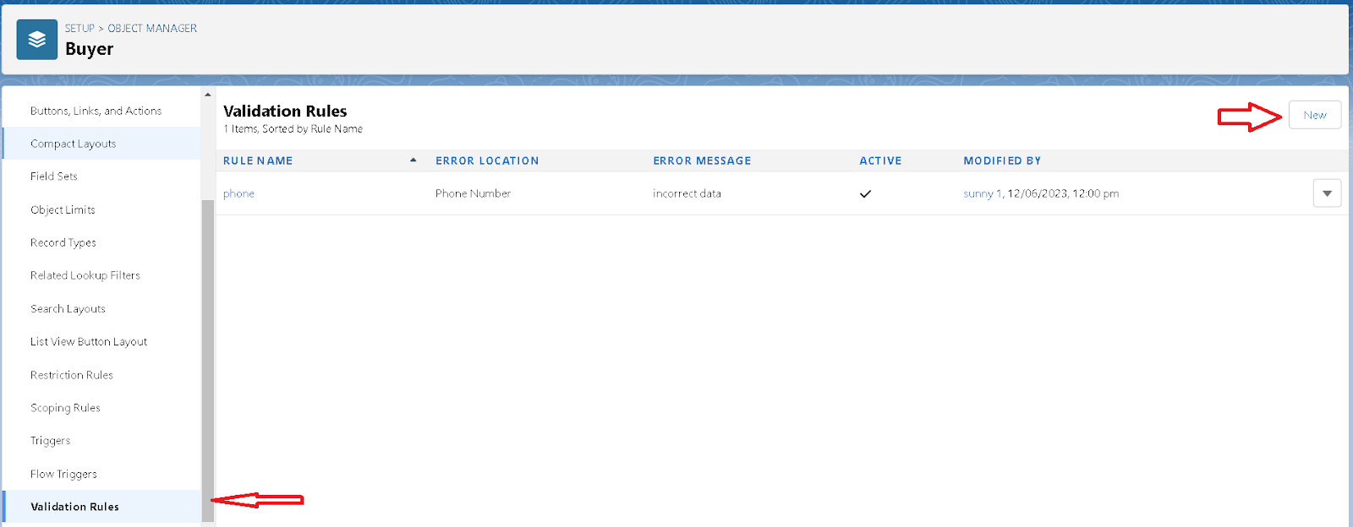

* Enter the Rule name as “Phone ”.
* Insert the Error Condition Formula as : -

**NOT(REGEX( Phone_Number__c , "[6-9]{1}[0-9]{9}"))**

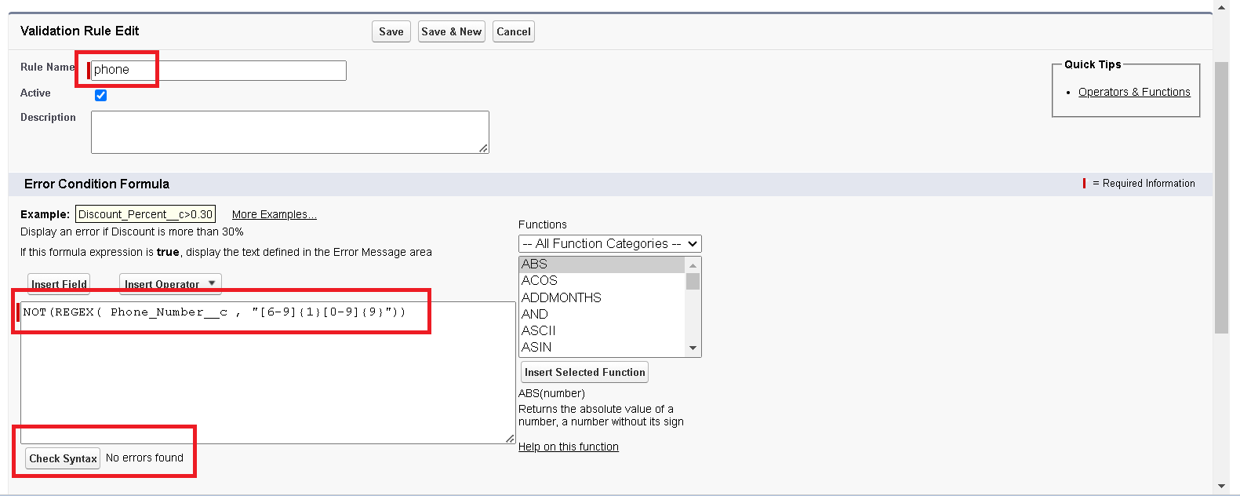

* Enter the Error Message as “ incorrect data”, select the Error location as Field and select the field as “phone number”, and click Save.

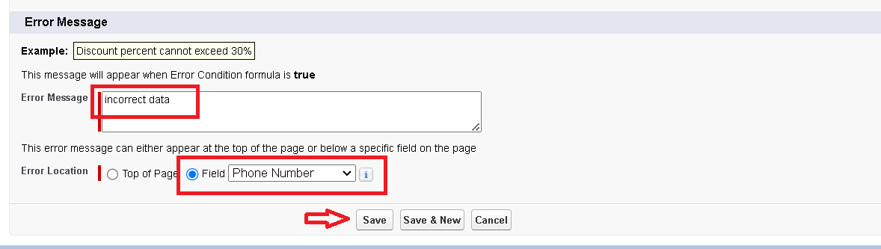

### Creating Remaining Fields in Objects:

* Check the remaining fields if need or uh want to create.

### Page layouts:

Page layouts in Salesforce are essential tools that administrators use to control the organization and presentation of fields, related lists, custom links, and other elements on record detail and edit pages. By customizing page layouts, admins can tailor the user interface to fit the specific needs of different users and ensure that they have access to relevant information and functionalities.

**To Create a Page layout:**

* Click on object manager->click on buyer object->click on page layout->click on New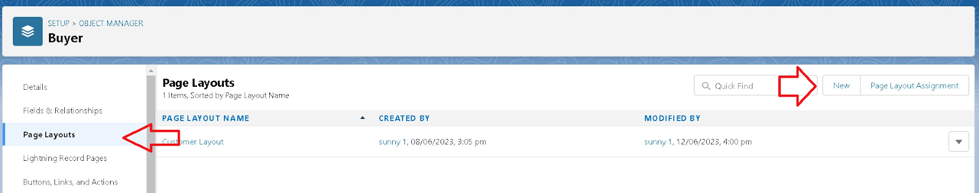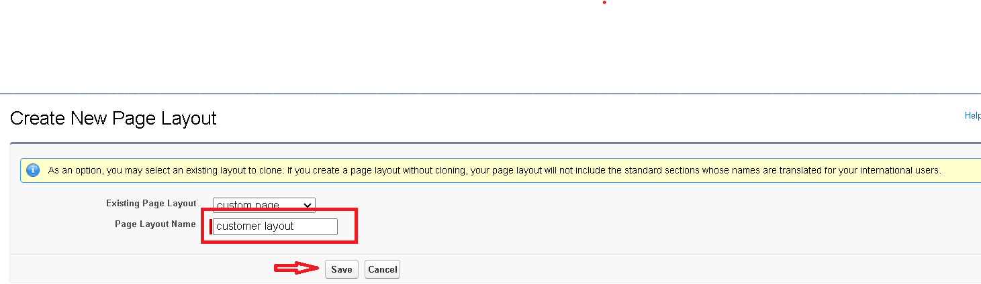
* Drag and drop the section field to the buyer field and create the section->enter the section field as "Personal details"

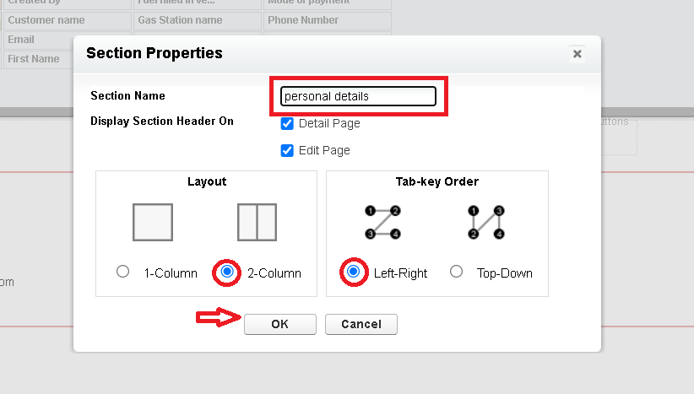

* Enter the field name as First name , last name , customer name , phone number, email, Gas station name.
* Follow the same process for another two sections as shown above , they are

One section is “ vehicle info ” , drag the fields that are

* Fuel filled in vehicle, vehicle type.
* Another section is “Recepit details ”, and drag the fields that are
* Mode of payment , Amount paid.
* Then , Click save.

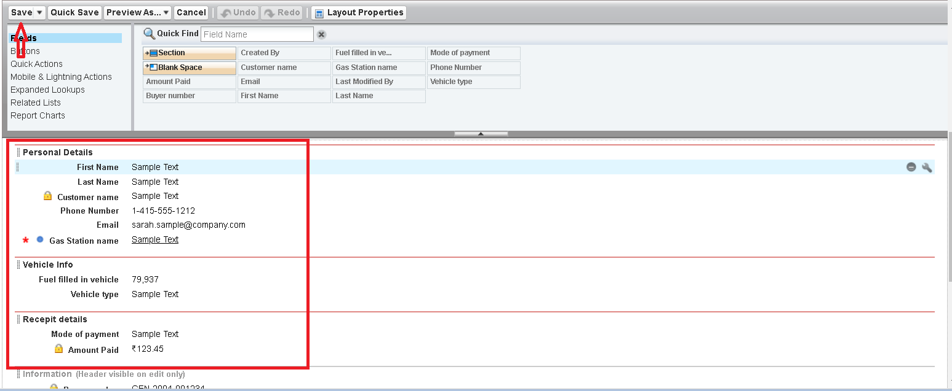

### Profiles:

### Profiles in Salesforce play a crucial role in defining the access and permissions of users within the Salesforce environment. They determine what users can see and do within Salesforce, ensuring that data and functionalities are available only to the right people. As a Salesforce Admin, managing profiles is essential for maintaining security, compliance, and efficient workflows.

### Manager Profile:

* Go to profiles->clone the desired profile->Enter the profile name

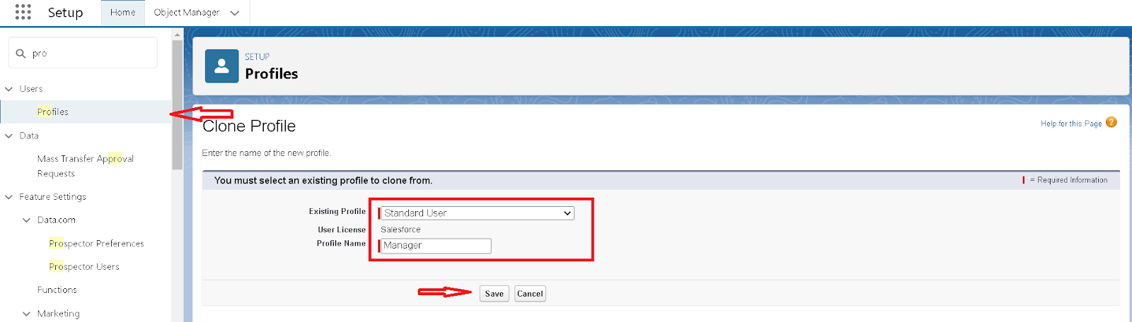

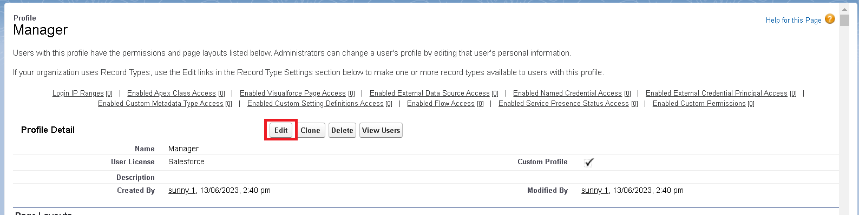

* In Custom App Setting

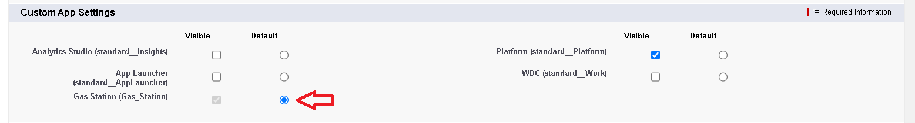

* Scroll down to Object Permissions

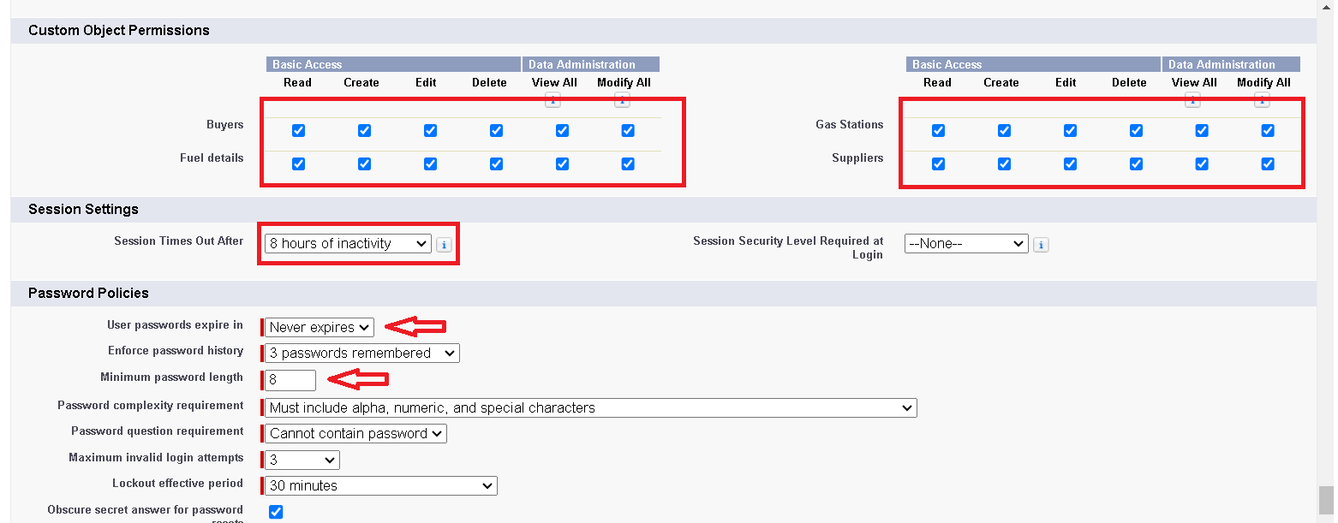

See the Above Pictures and enter the details. and save.

### sales executive Profile:

* Do the same as above and change only below one and click on save.

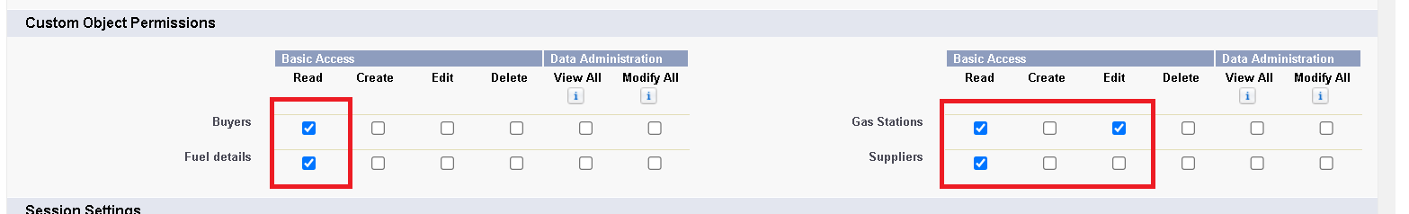

### sales person Profile:

* Do the same and change as below figure and click on save.

Role & Role Hierarchy:

Roles and role hierarchies in Salesforce are fundamental concepts for managing data visibility and access within an organization. They help in defining how records are shared and accessed among users, ensuring that the right people have the right level of access to the information they need to perform their jobs effectively.

**Creating Manager Role:**

* In Quick find search for Roles->click on setup roles.

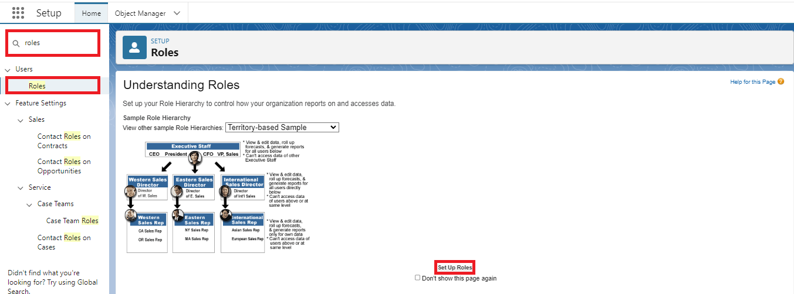

* Click on Expand All->click on add role.

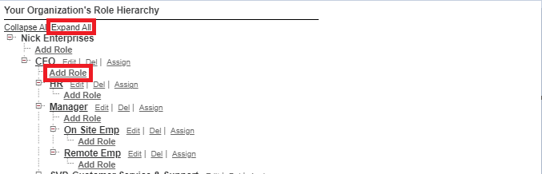

* Enter Label name as "Manager"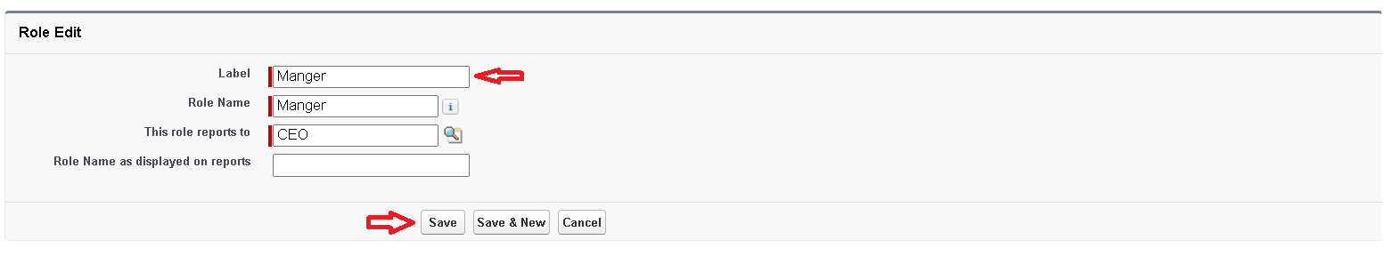

### Creating another roles:

* Under Manager which is named as Sales Person and Sales Executive

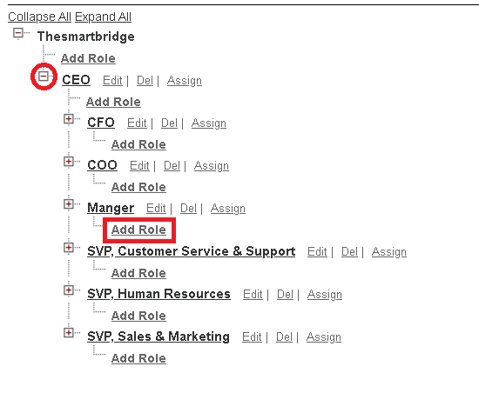

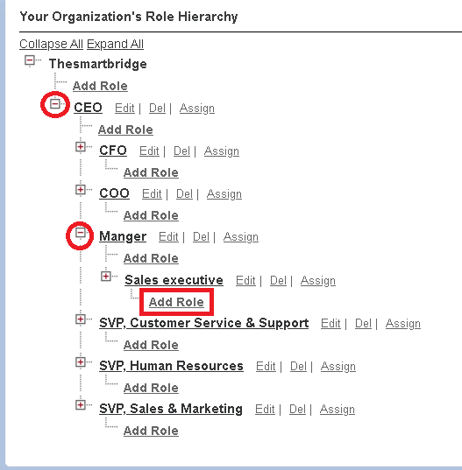

### Users:

A user is anyone who logs in to Salesforce. Users are employees at your company, such as sales reps, managers, and IT specialists, who need access to the company's records. Every user in Salesforce has a user account. The user account identifies the user, and the user account settings determine what features and records the user can access.

### Create User:

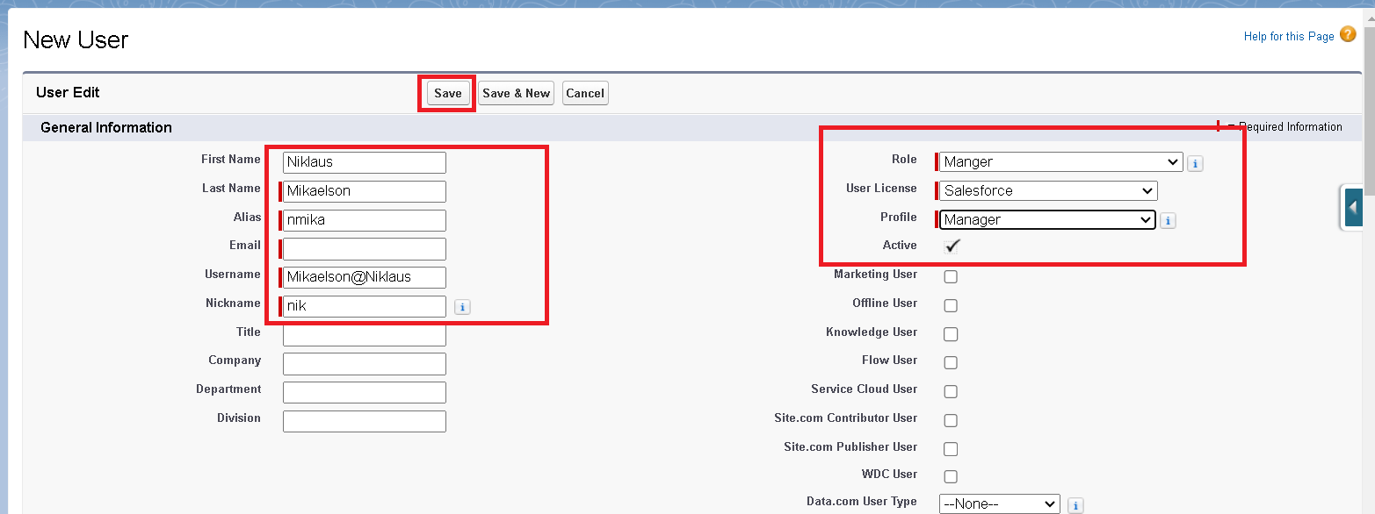

* Go to setup ->type users in quick find box -> select users ->click New user.
* Fill in the fields
  + First Name : Niklaus
  + Last Name : Mikaelson
  + Alias : Give a Alias Name
  + Email id : Give your Personal Email id
  + Username : Username should be in this form: text@text.text
  + Nick Name : Give a Nickname
  + Role : Manager
  + User licence : Salesforce
  + Profiles : Manager
* Save

### creating another users

* Follow the same steps from above activity and create another user using
  + Role : sales executive
  + User licence : Salesforce Platform
  + Profile : sales executive
* Repeat the steps and create another user using
  + Role : sales person
  + User licence : Salesforce Platform
  + Profile : sales person

Permission sets

A standard permission set consists of a group of common permissions for a particular feature associated with a permission set license. Using a standard permission set saves you time and facilitates administration because you don't need to create the custom permission set.

Creating permission set:

* Go to setup->search for "Permission sets" ->New->Enter the label name as "P1"->Save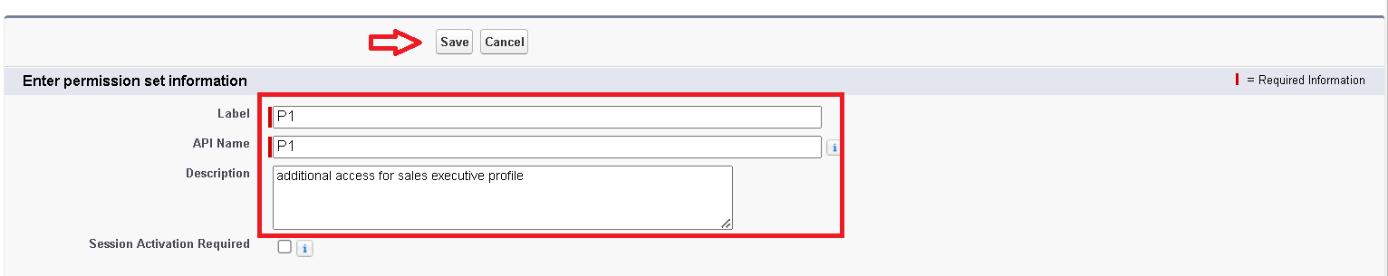
* Click on Under Apps We have Object settings

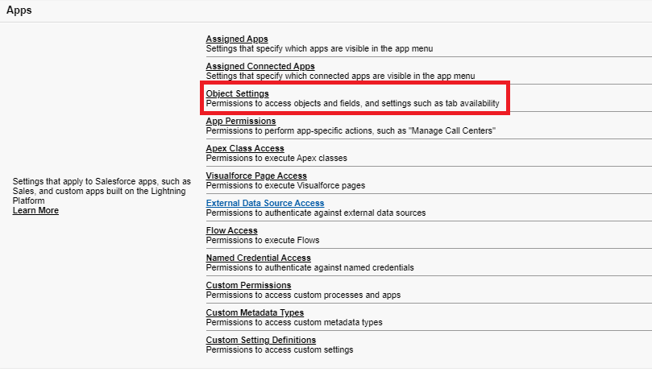

* Click on Fuel Object->edit-> check the read and Create box ->save

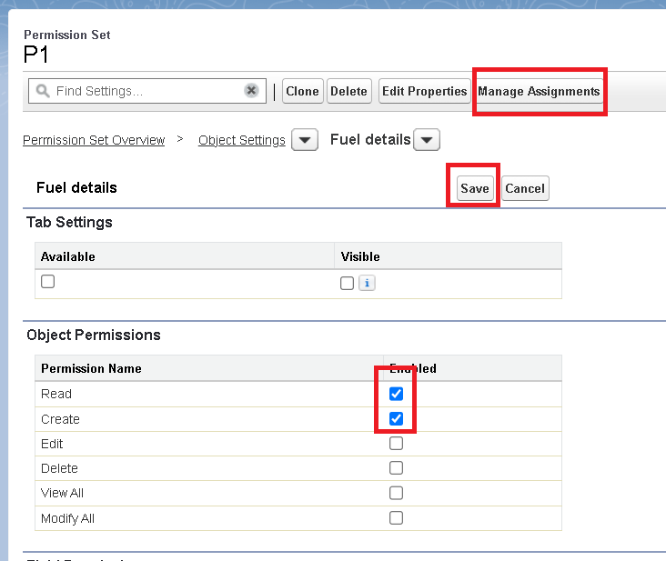

* Go to Manage Assignments->Click on Add Assignments->Select the user that we Created pervious->click on Next

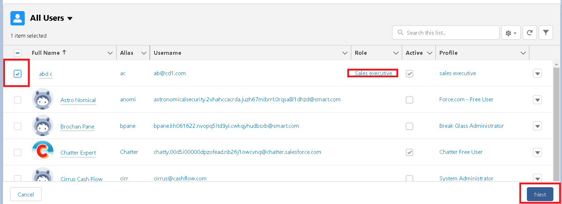

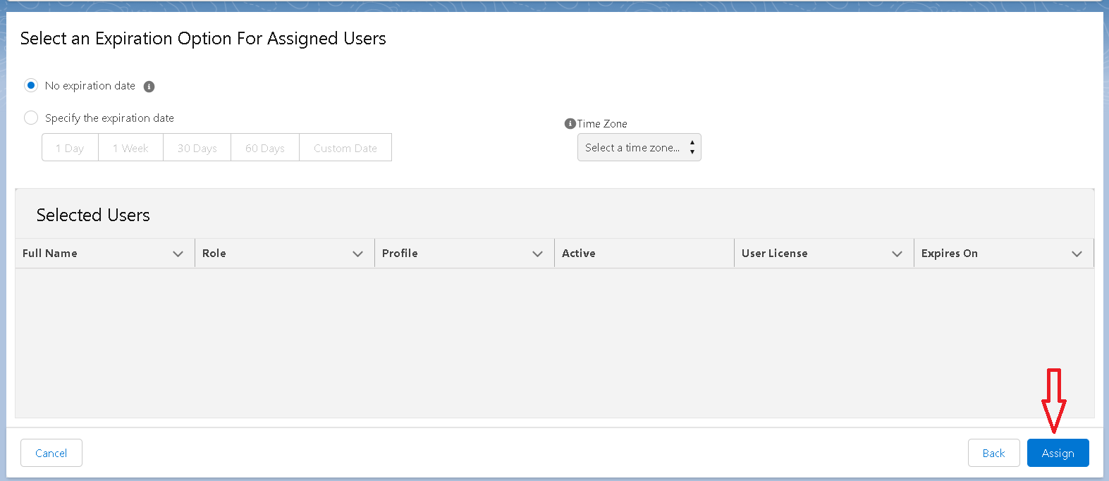

* Click on Next->Done.

### Setup For OWD:

Organization-Wide Defaults, or OWDs, are the pattern security rules that you can follow for your Salesforce instance. Organization Wide Defaults are utilized to confine who can access what information in your CRM. You can award access through different methods that we will discuss later (sharing principles, Role Hierarchy, Sales Teams, and Account groups, manual sharing, and so forth).

Primarily, there are four levels of access that can be set in Salesforce OWD and they are-

* Public Read/Write/Transfer (only available of Enquiry and Cases)
* Public Read/Write
* Public Read/Only
* Private

### Creating OWD Setting:

* Go to setup->type "Sharing Settings" ->Click on Edit.

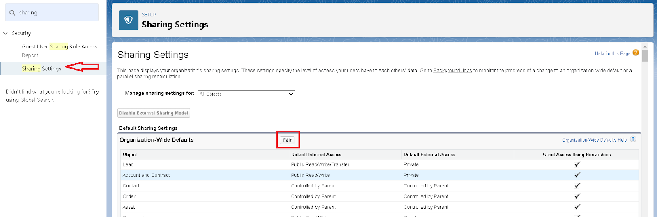

* Scroll down and for Gas Station and Supplier keep as "Public Read Only" ->save

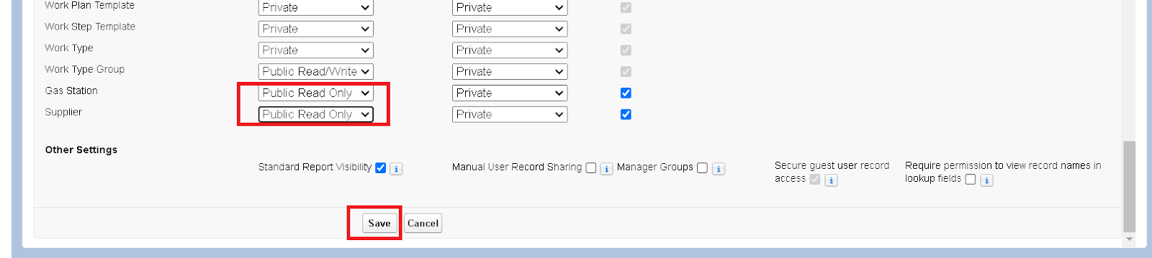

### User Adoption:

User adoption in Salesforce refers to the process of ensuring that all users in an organization fully utilize and embrace Salesforce to its maximum potential. It involves not just getting users to log in and perform basic tasks but also ensuring they leverage the platform's full capabilities to improve their productivity, efficiency, and data accuracy. Successful user adoption leads to higher return on investment (ROI) and better business outcomes.

### create a record:

* To create a record in junction object follow these steps
* Click on the app launcher locate at left side of the screen.
* Search for “ Gas station” and click on it.
* Click on “ fuel details tab”.
* Click on new and fill the details as shown below figs, and click save.

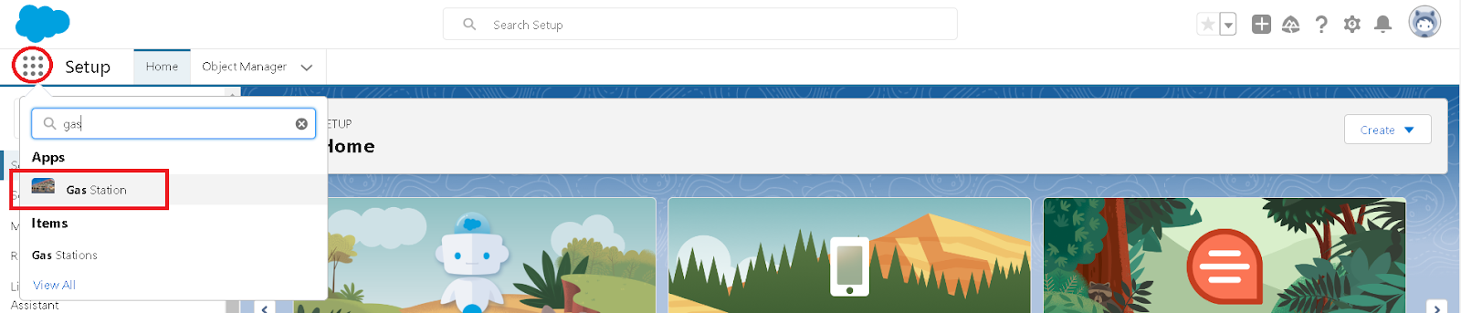

* Creating the supplier record in fuel detail record, by clicking the “ new supplier ”.

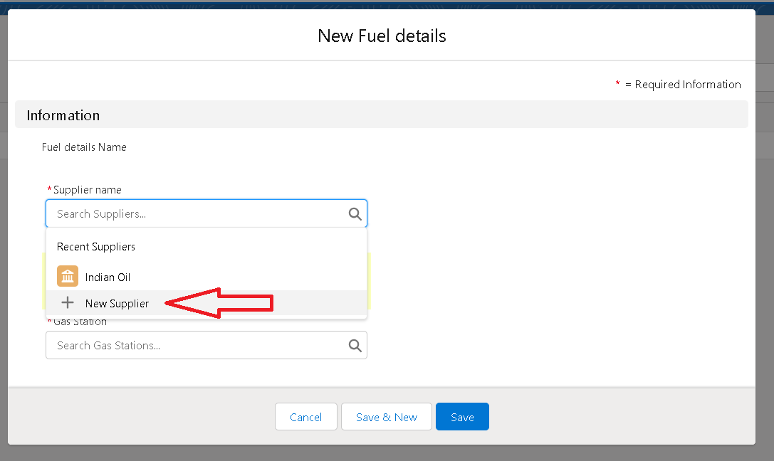

* Fill the Details

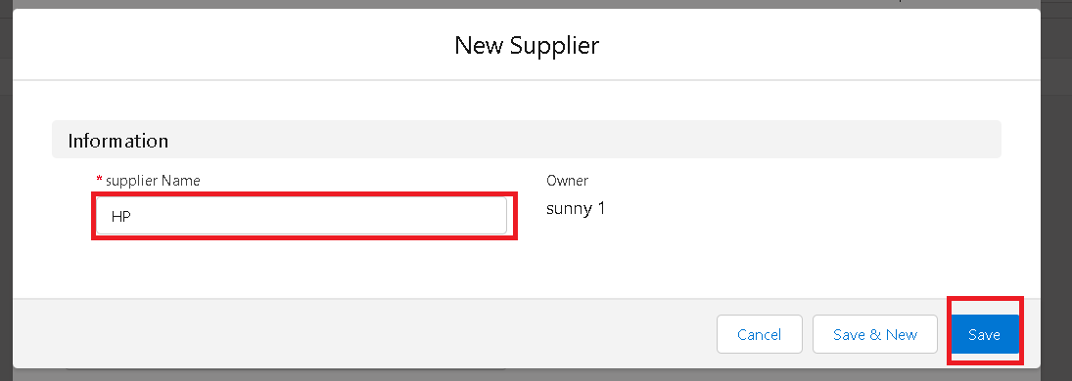

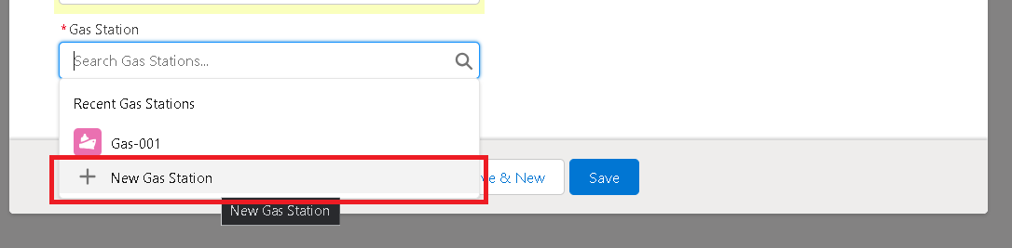

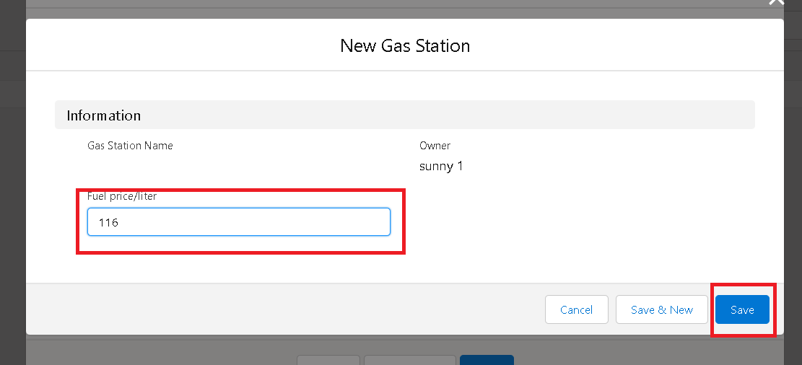

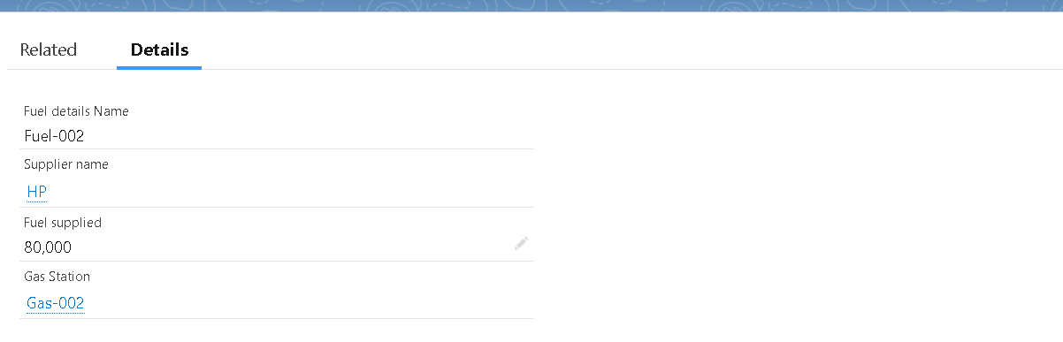

* After filling click on save and create some more for the better understanding

### View a record

* We have already created for view the records that we already created.

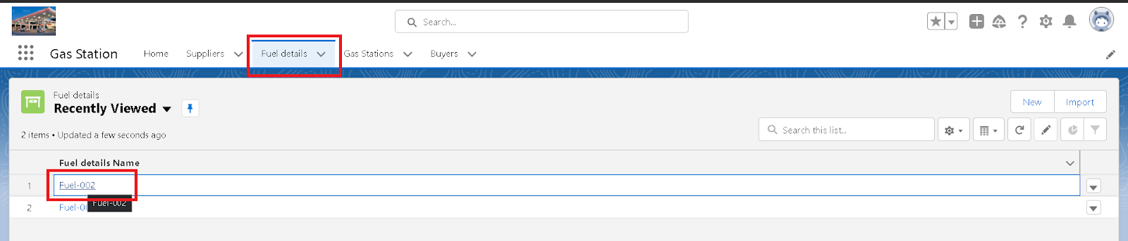

### Delete a record

* We can also delete the record if we need.

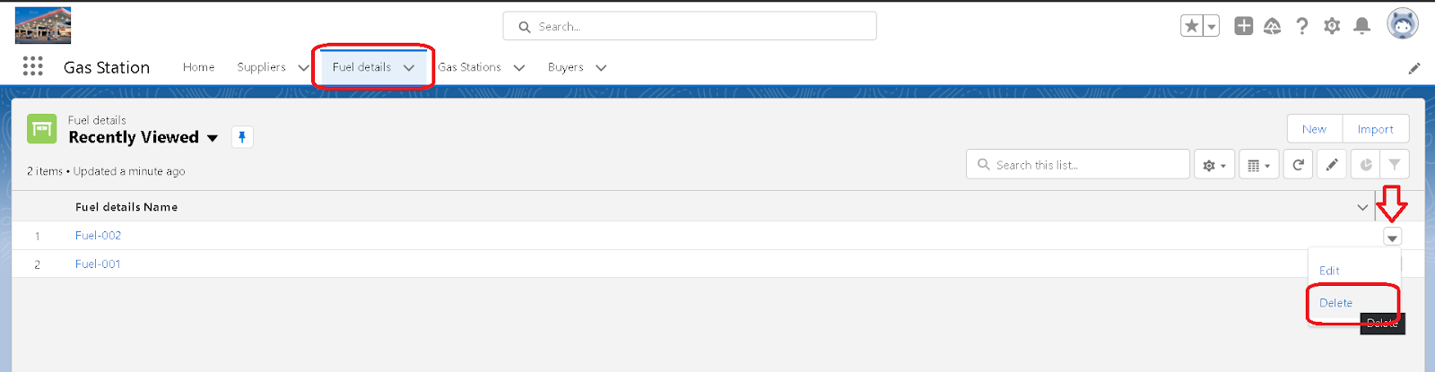

### Reports:

Reports give you access to your Salesforce data. You can examine your Salesforce data in almost infinite combinations, display it in easy-to-understand formats, and share the resulting insights with others. Before building, reading, and sharing reports, review these reporting basics.

* Types of Reports in Salesforce
* Tabular
* Summary
* Matrix
* Joined Reports

### create a report folder:

* Click on App Launcher->Go to Reports->Give the folder label as "Fuel Estimation"->save

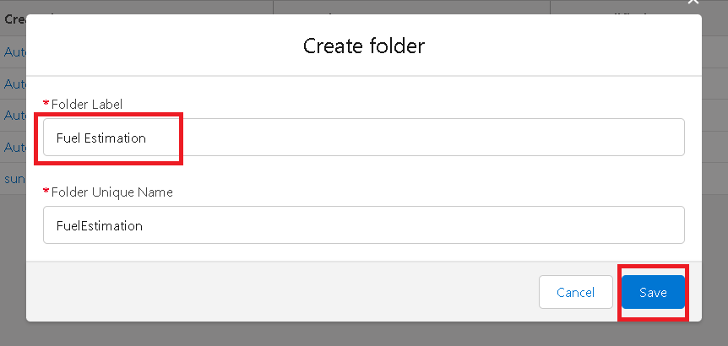

### Sharing a report folder:

* Again Click on Report tab->Click on All Folder->click on Fuel Estimation folder and Share

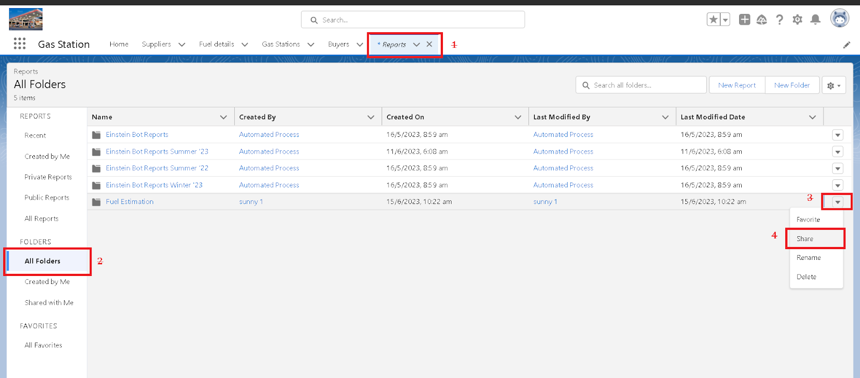

* And select the roles as below figure \

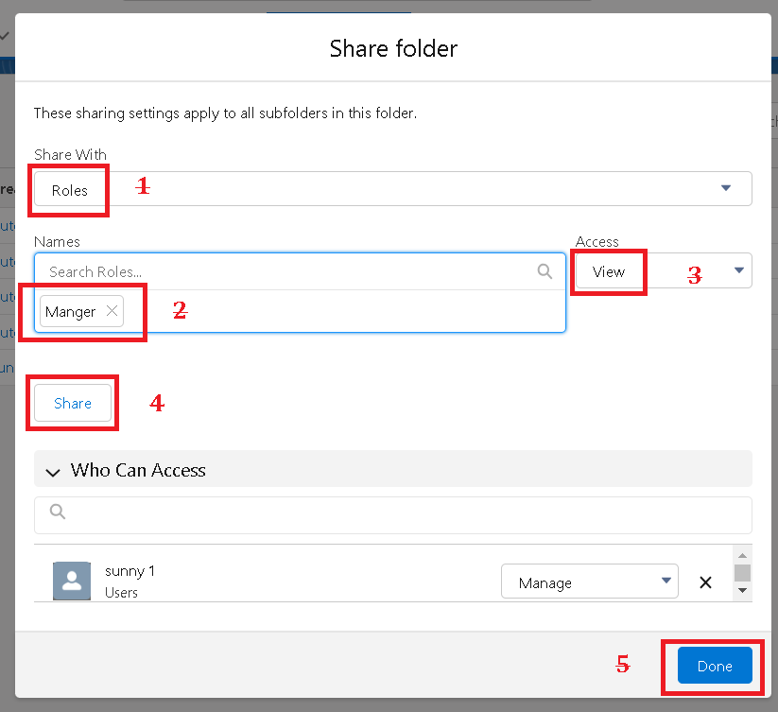

### Create Report:

* Go to App->Report tab->New Report

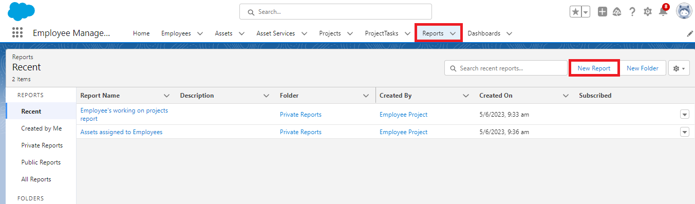

* Select Report Type->Search for "Gas Station with buyer"

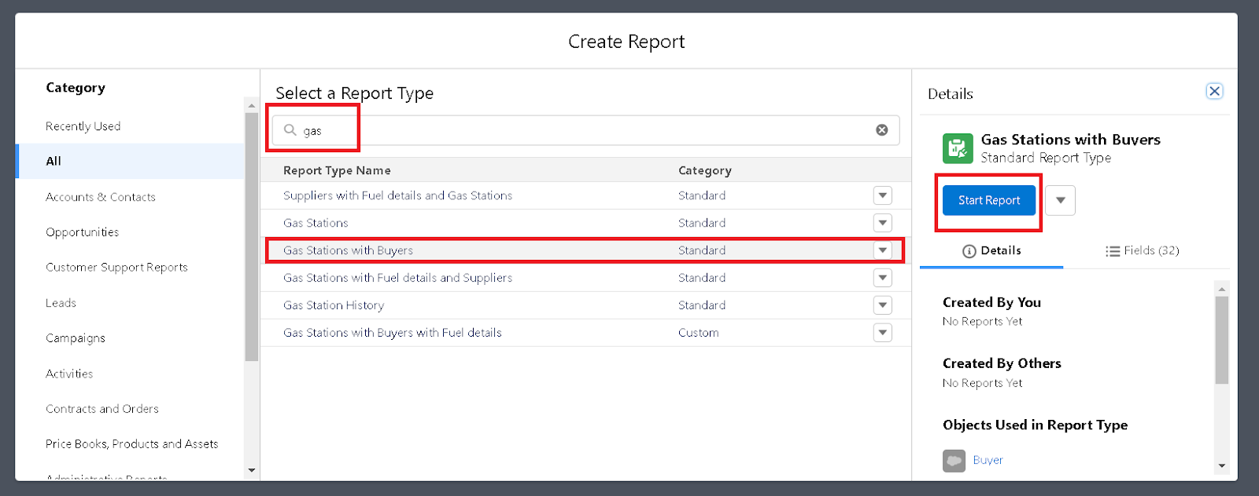

* Sort the details as Below

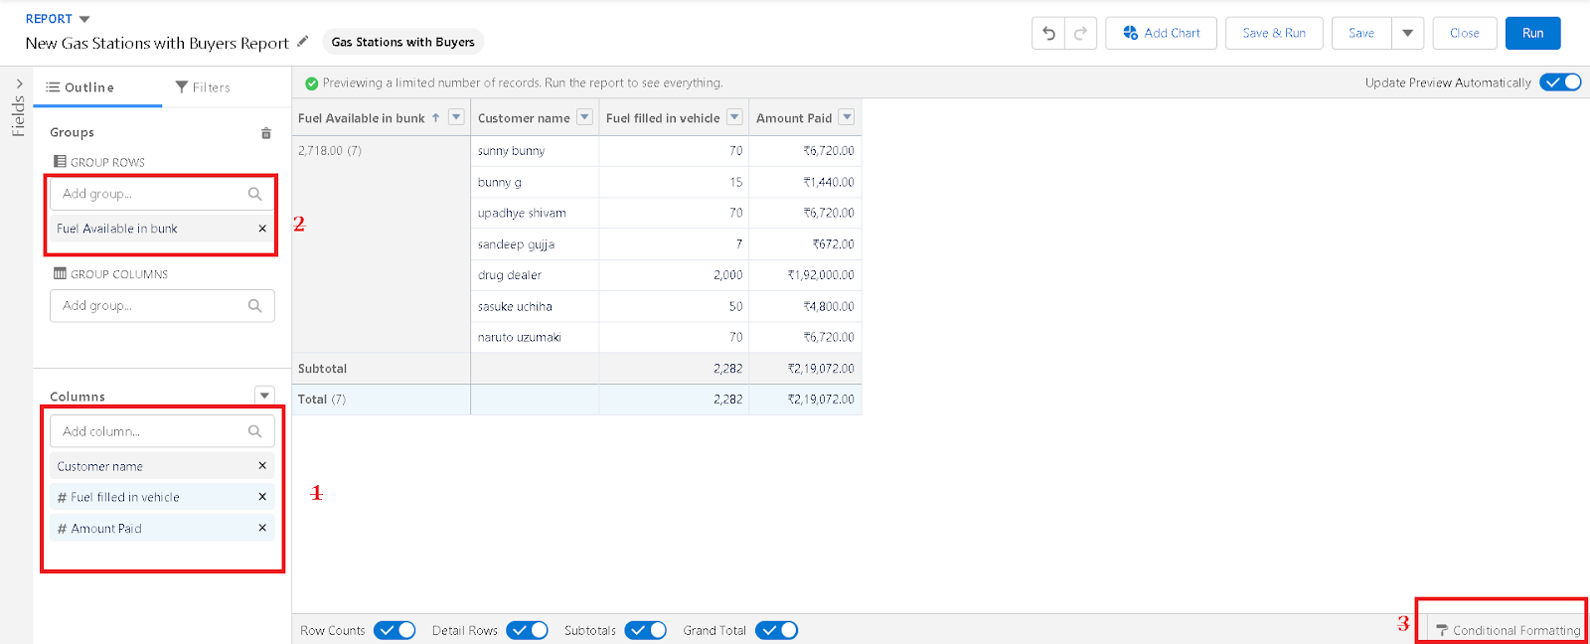

* Click on Conditional Formating->Apply it as "Sum of Amount Paid"
* **Range:**1000-5000 ->Apply

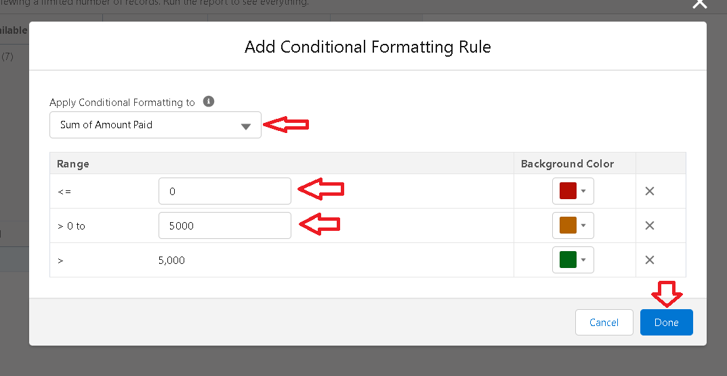

* Click save, give the report name as “Amount range”, report unique name will be auto populated.
* Click on select folder, select “ Fuel estimation” , click select folder ->save

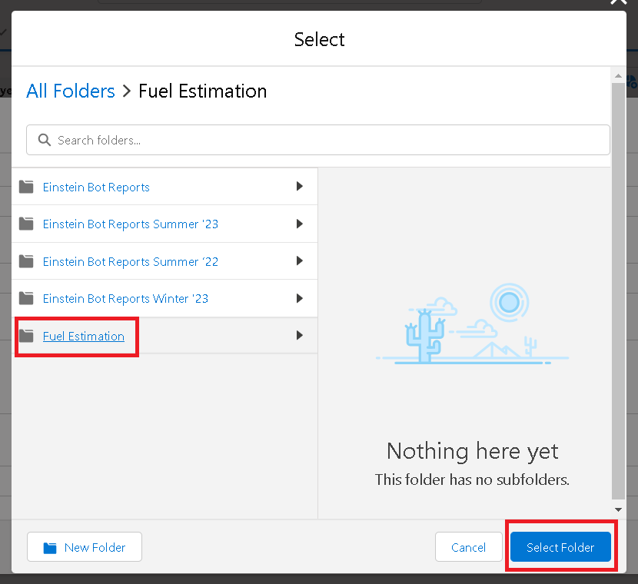

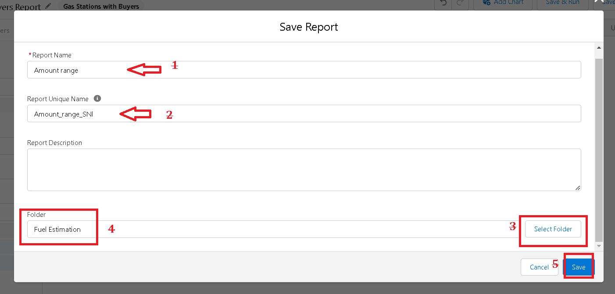

* Click save and Run.

### Dashboards:

Dashboards help you visually understand changing business conditions so you can make decisions based on the real-time data you’ve gathered with reports. Use dashboards to help users identify trends, sort out quantities, and measure the impact of their activities. Before building, reading, and sharing dashboards, review these dashboard basics.

### Create Dashboard Folder

* Click on the app launcher and search for dashboard.
* Click on dashboard tab.
* Click new folder, give the folder label as “ Amount estimation dashboard”.
* save and provide sharing setting for the folder as below activity

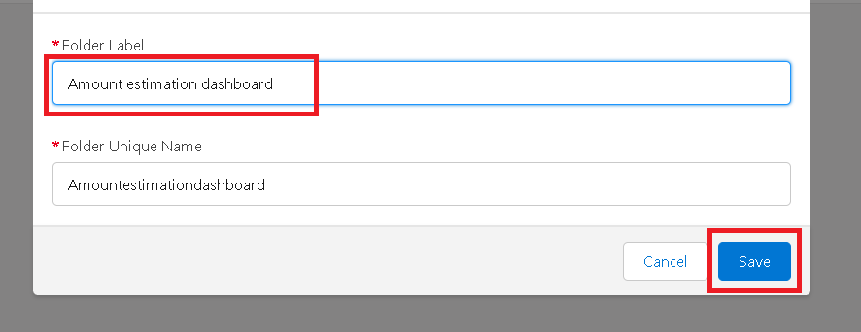

### Create Dashboard:

* Go to Dashboard Tabs

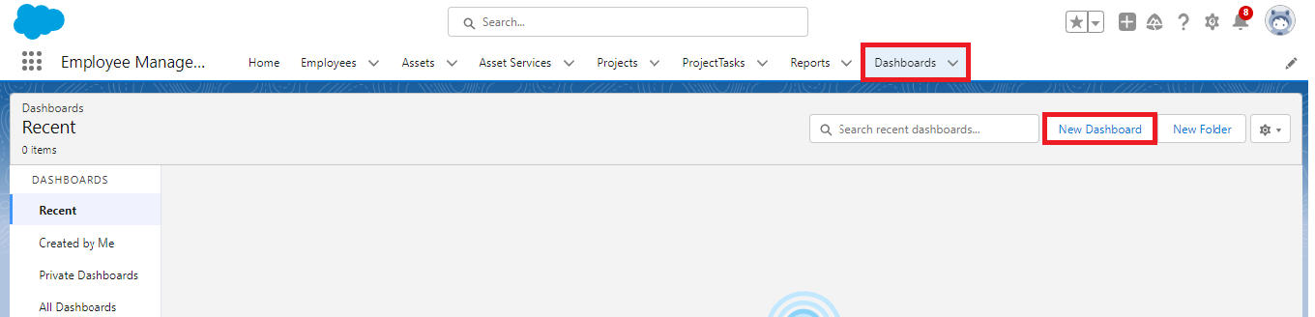

* Give the Name and Create a Folder->Add the Widget->Chart



* Select Report and Save

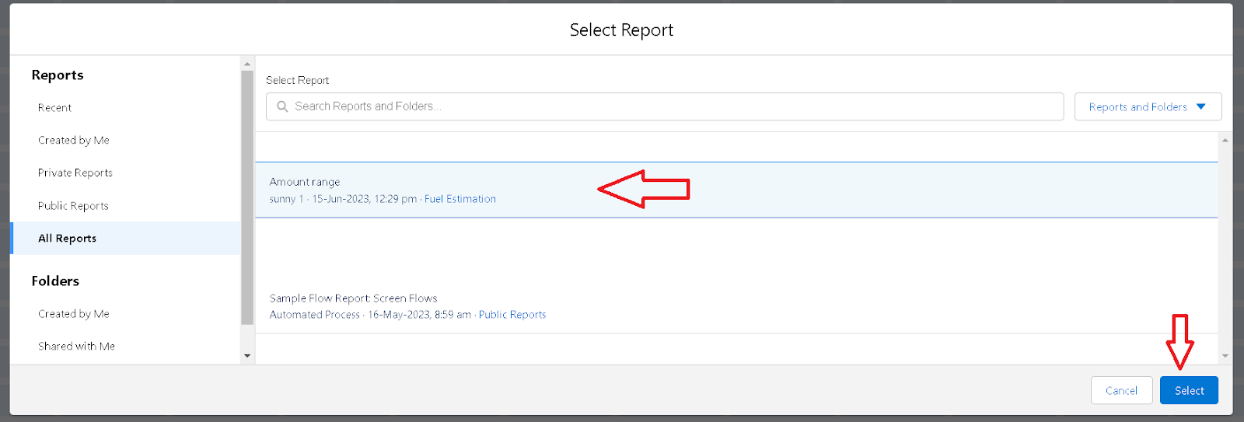

### Flows:

In Salesforce, a Flow is a powerful automation tool that allows you to build complex business processes without writing code. Flows can collect data from users, perform calculations, execute logic, and interact with Salesforce records. They are part of Salesforce’s declarative automation suite, which also includes Process Builder and Workflow Rules.

### Create a Flow:

* Go to setup ? type Flow in quick find box ? Click on the Flow and Select the New Flow.

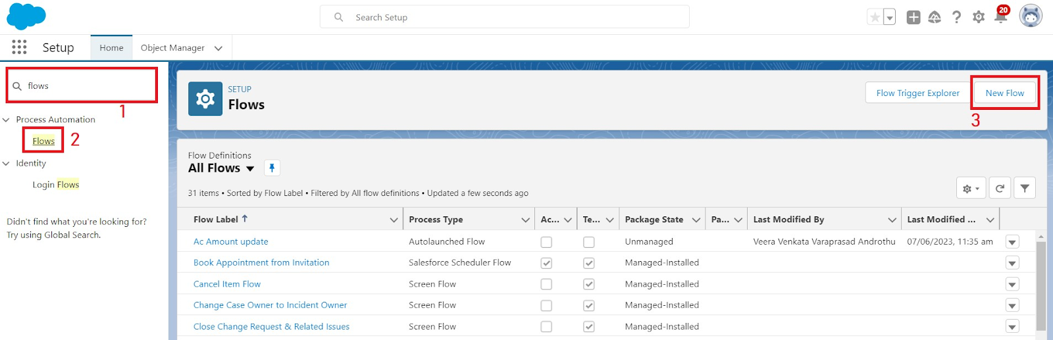

* Select the Record-triggered flow and Click on Create;.

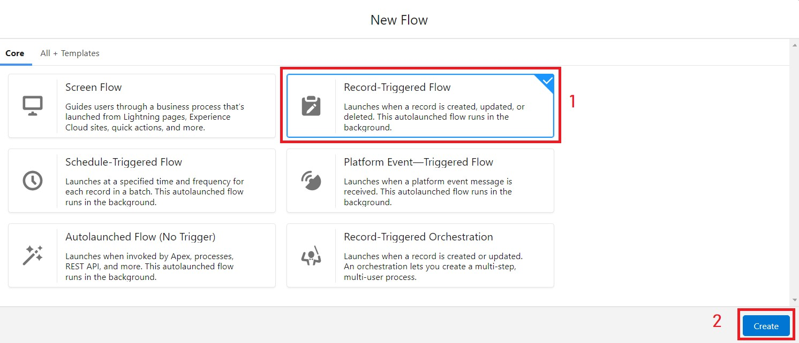Select the Object as a “buyer” in the Drop down list.

* Select the Trigger Flow when: “A record is Created or Updated”.
* Select the Optimize the flow for: “Actions and Related Records” and Click on Done Now change the mode form Auto-layout to free-form.
* Now select the manger option in toolbox, click New resource.
* Select the resource type as text template.

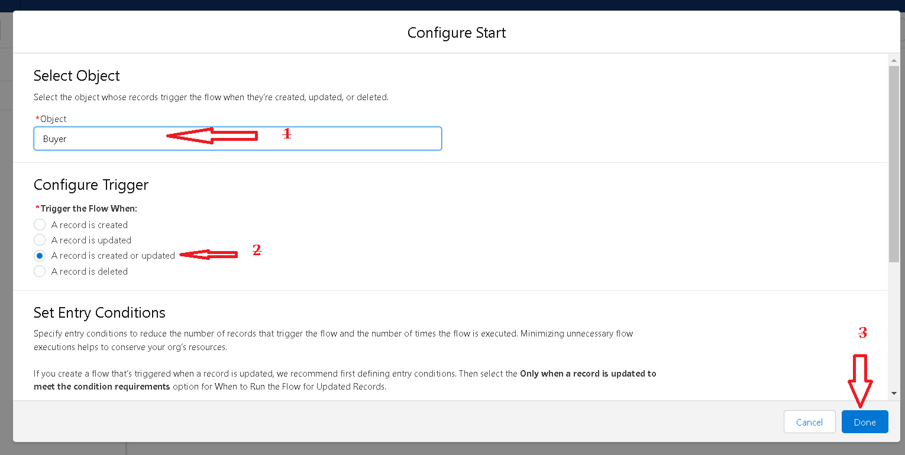

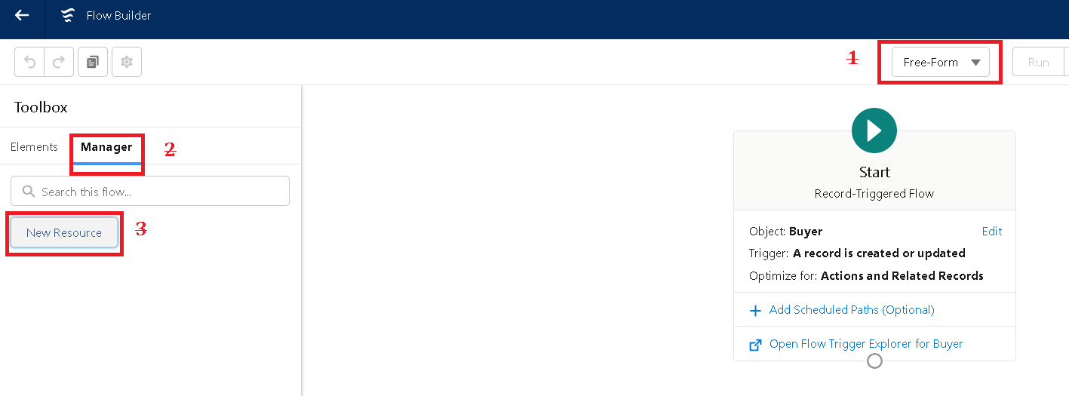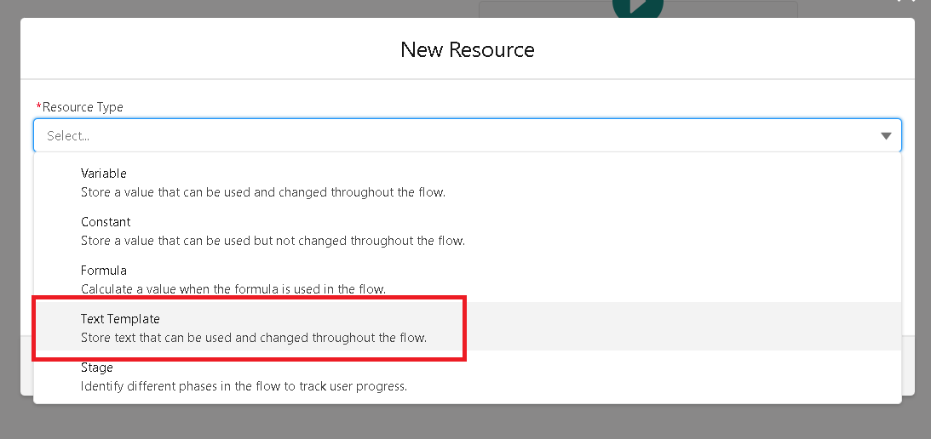

* Enter the API name as “ emailbody”.
* In body field paste the syntax that given below.
  + Hello {!$Record.Customer_name__c},
  + Thank you for coming , we are glad and considering that we provided the best survise.
  + RECEPIT DETAILS :
  + Customer name : {!$Record.Customer_name__c}
  + Amount paid by Customer : {!$Record.Amount_Paid__c}
  + Vehicle type : {!$Record.Vehicle_type__c}
  + Fuel intake in vehicle : {!$Record.Fuel_filled_in_vehicle__c}
* Change the view as Rich Text ? View to Plain Text.
* Click done.

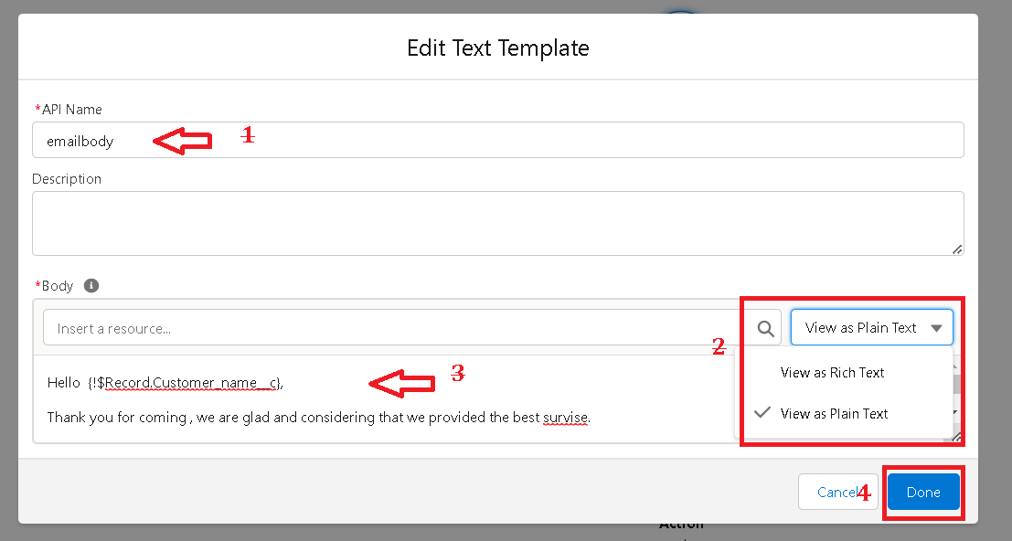

* Click on Action Bar and send the email
* Give the label name as “ notice”
* API name will be auto populated.
* Enable the body in set input .values for the selected action.
* Select the text template that created 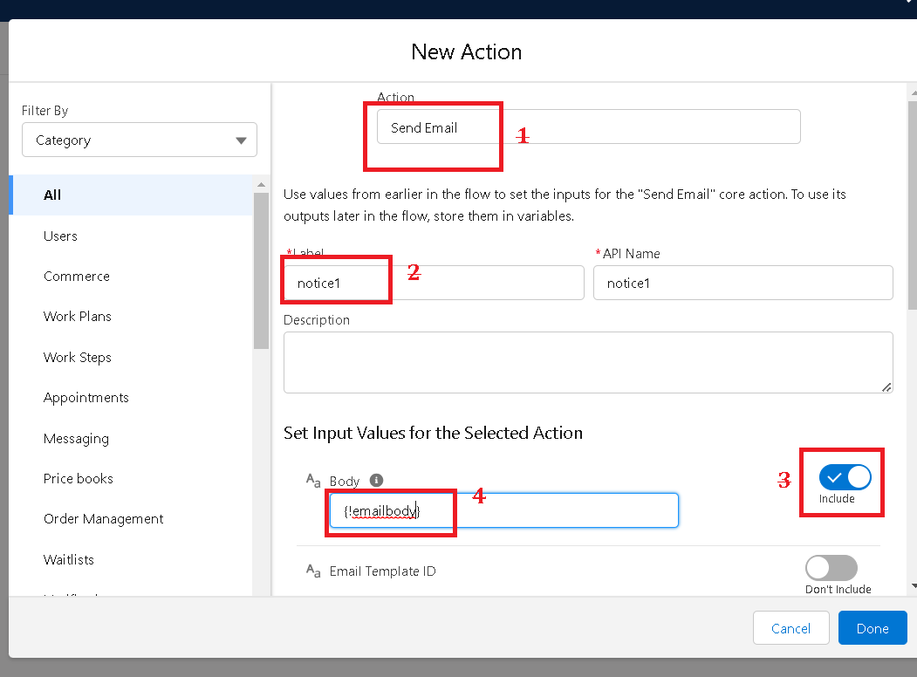 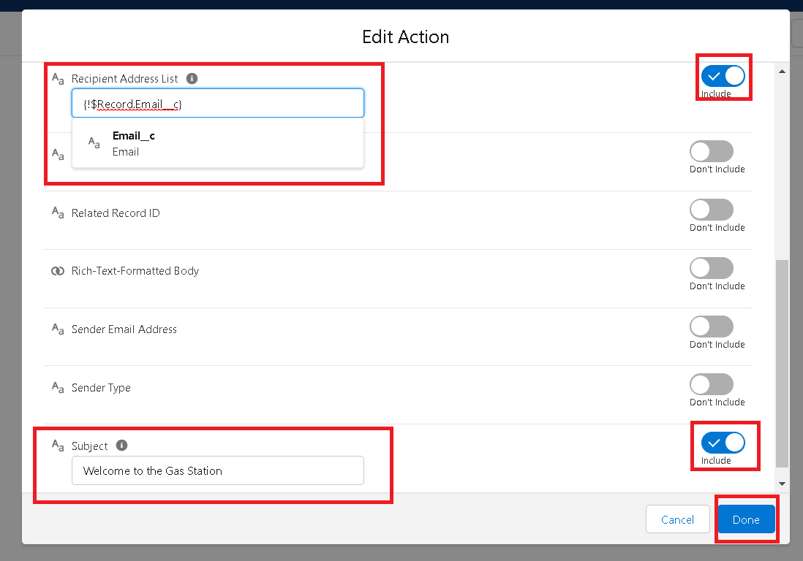

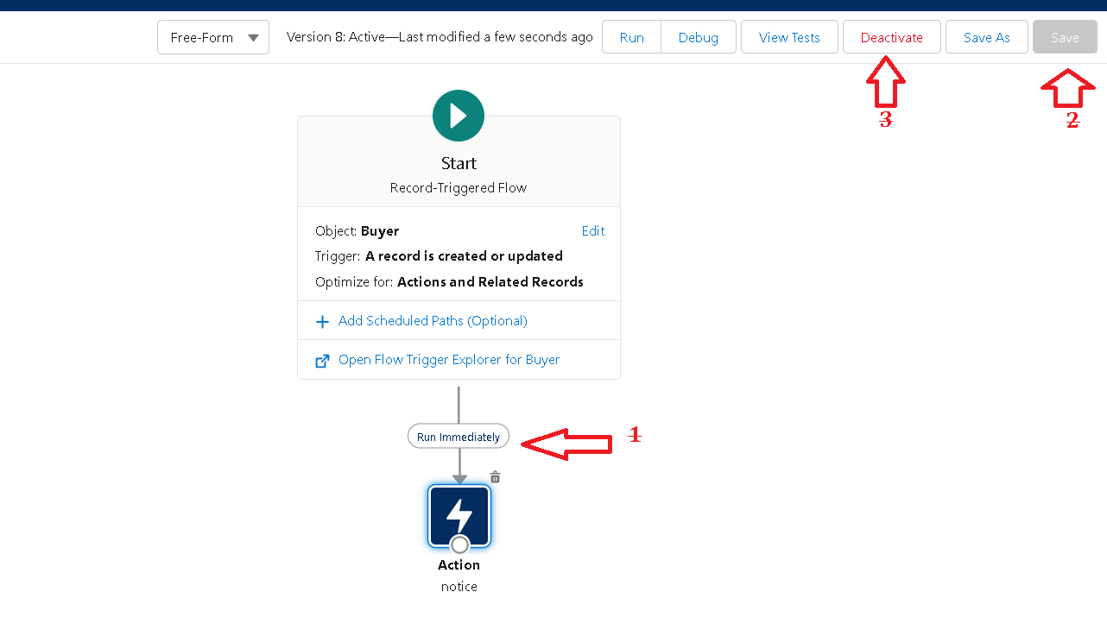

* Save

***THANK YOU***